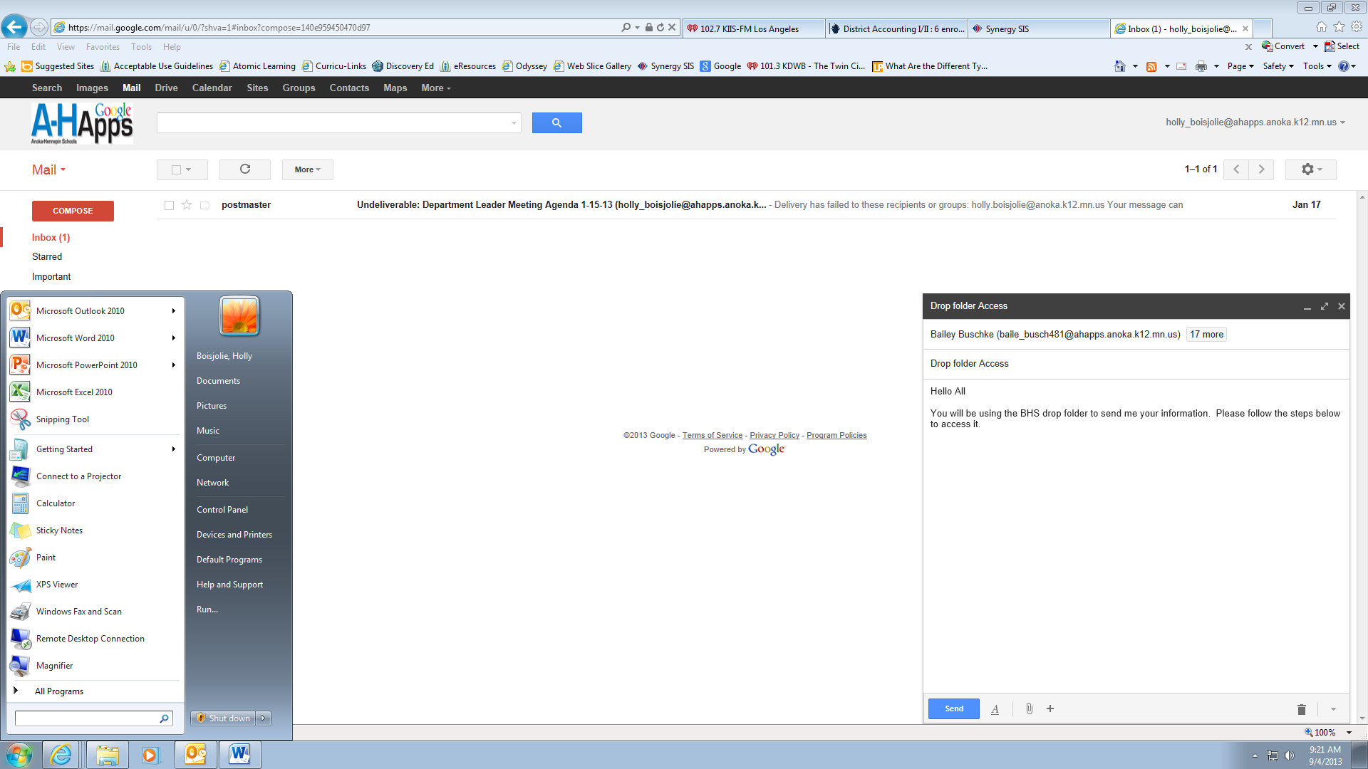

Step 2: Click here

Step 1: Click here

Type in the following an click ok

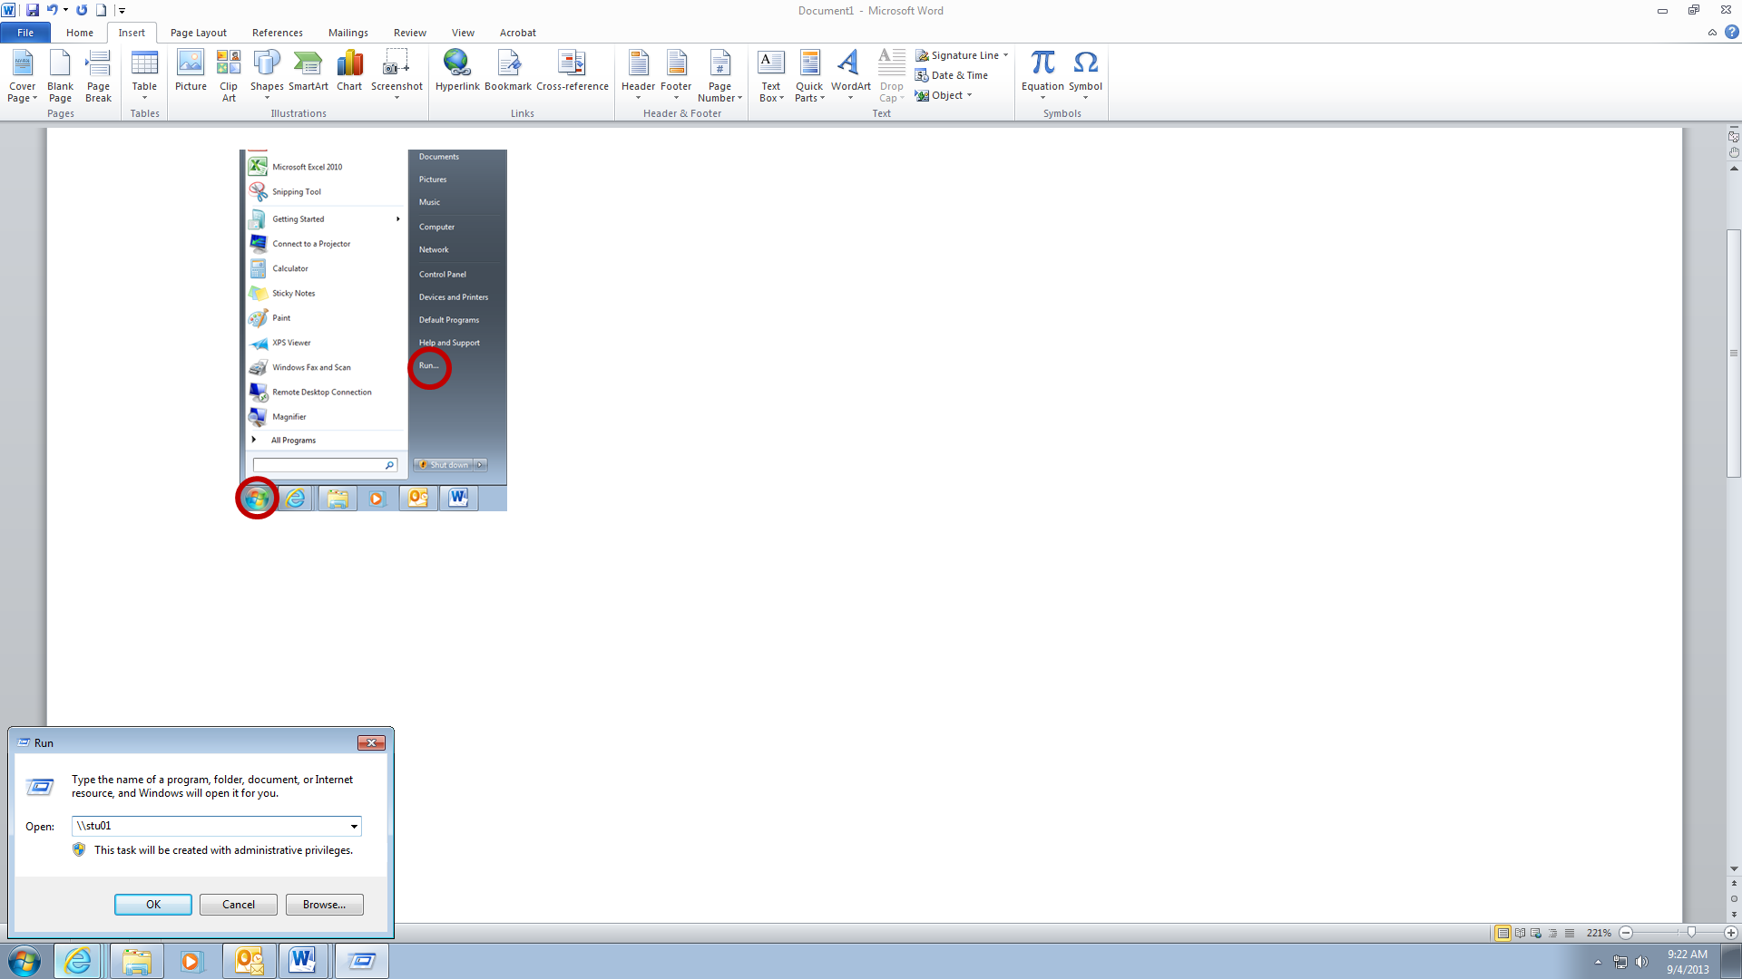

Step 3: type in [\\stu01](file:///\\stu01) and click ok

Or you can hold the CTRL button and click on the hyperlink above

The following box will open and from there you will click

* Student Drop
* CRHS
* Bodenburg
  + Social Media Marketing and Web Design

This is where you will put the documents that I will specify. Any questions please let me know.

